**To Install on Weapon:**

Make sure the Weapon is cleared and unloaded with the safety on, and muzzle pointed in a safe direction. Ensure the SIDELOK is preloaded for installation by pressing the button in while simultaneously depressing the safety lever with the tip of your finger. The button will lock in the rearward position with the side locking bar out. On a clean, debris free picatinny rail, align the opposite side of the mount base with the 45 degree angle on the rail. Make sure the recoil lug lines up with the preferred T-slot in the rail. Roll the optic/mount on the rail. Once rolled on, a release lever will fire a cam that will deploy the side locking bar, securing the optic to the weapon. Your optic is now installed. To remove, push the button and roll off in the opposite direction.

**For Questions or Help email:**

**info@kineticdg.com**

INCLUDED IN THE KIT

(x1) Allen Wrench

(x1) SIDELOK Scope Base

(x2) Match Sets Precision Machined Scope Rings

(x1) Blue Vibratite Pack

(x13) 8-32 x 5/16” Socket Head Cap Screws

**Congratulations on your purchase of the SIDELOK QD Mount System.** This is the world’s easiest to install optics mount, and a true return to zero mounting system. It allows you to quickly configure your rifle for your current mission. If you have previously zeroed the optic with the recoil lug in a particular slot of the picatinny rail, your optic will lock on identically with each install ensuring your zero is maintained from its last use. The automatic mechanical cam system (Pat. Pending) of the SIDELOK provides the user consistency during installations, eliminating common variables like tensioned throw levers and user error.

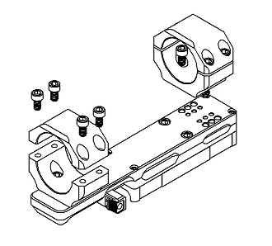

**To install optic:**

**Step 1:** The mount will be loosely assembled to protect parts in shipping. Remove screws from scope rings and separate from SIDELOK Scope base.

**Step 2:** Select the desired location that the bottom half of the scope ring will sit. Dowel pins will align screw holes to ensure proper mounting of ring to base. Apply a drop of blue Vibratite (included) to the threads of (x4) of the 8-32 x 5/16” socket head cap screws included. (Ensure screws are clean of oil and grease prior to using). Lock bottom half of scope ring onto base. Max torque at 17 in - lbs.

**Step 3:** Place optic into bottom half of scope ring and cover with matching top half (RING SETS WILL HAVE MATCHING DIMPLES). Apply a drop of blue Vibratite to the threads of the remaining (x8) 8-32 x 5/15” socket head cap screws and loosely assemble. Make sure the scope is level before torqueing down. Ensure equal torque is applied to each screw working back and forth until secure. Max torque at 17 in – lbs. OVER TORQUEING CAN DAMAGE OPTIC AND MOUNT.